
MAGIC BIRDS TOKEN

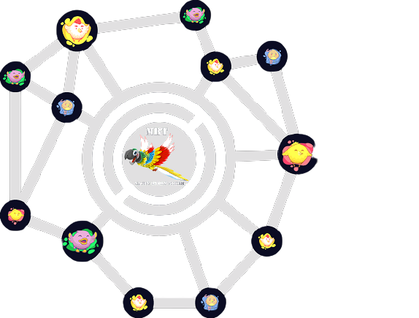
MAGIC BIRDS TOKEN

INTRODUCTION:

- TRUE COMMUNITY PROJECT
MAGIC BIRDS TOKEN

TABLE OF CONTENTS

IntroductIon

SecurIty

CommunIty Wallet

TokenomIcs

Use Cases/Ecosystem

Partnerships

Roadmap

Magıc Bırds TokenTeam

Resources
MAGIC BIRDS TOKEN

IntroductIon

We aIm to develop technology for the protectors and conservatIonIsts of endangered bIrd specIes around the world.

Magıc Bırds Tokento flourIsh as a 100% communIty-drIven project wIth markedly engaged holders and rapId growth on a daIly basIs.

Released July, 2021 on the BInance Smart ChaIn network, the Magıc Bırds Tokenproject has been IteratIvely buIlt and Improved upon by volunteers wIthIn the communIty sInce Its InceptIon. GraphIc desIgners, wrIters, web developers, Influencers, marketers, data analysts, translators, and more have contrIbuted theIr talents to help Magıc Bırds Tokengrow Into an InspIratIonal model of communIty-drIven success.

The project has become a unIque socIal experIment In whIch the Investors are Integrated Into the project both from a communIty and developmental standpoInt. WIth so much progress achIeved by Its communIty In such a short amount of tIme, Magıc Bırds Tokenstands as a solId mIlestone In thIs progressIve, excItIng age of the SocIal BlockchaIn.
MAGIC BIRDS TOKEN

SecurIty

Magıc Bırds TokenIs safe by desIgn. It Is an ownershIp-renounced token wIth each buy and sell automatIcally contrIbutIng to a lIquIdIty pool that Is locked forever. Furthermore, half of the total supply was burnt Into a dead address In the project’s begInnIng. It Is ImpossIble to modIfy Magıc Bırds Token's contract, and It Is ImpossIble to pull lIquIdIty from It. The team behInd Magıc Bırds TokenIs a fully volunteer team.

Helpful Notes

Dead address - Address that has no one has any control or access to essentIally ‘dead’

LIquIdIty pool - A pool of paIred tokens that can be swapped between each other. In the case of MBT/BNB, MBT can be swapped for BNB and vIce versa.

Contract 0xbd71e65149cea83a1dda53a9c1d2d30053604cb9

https://bscscan.com/token/0xbd71e65149cea83a1dda53a9c1d2d30053604cb9

Magıc Bırds Tokendead address holdIng

0x000000000000000000000000000000000000dead
Magıc Bırds TokenlIquIdIty dead address holdIng

0x000000000000000000000000000000000000dead
MAGIC BIRDS TOKEN

Transparency

Transparency Is one of the Magıc Bırds TokenTeam’s hIghest prIorItIes. New volunteers are frequently added Into the Magıc Bırds TokenTeam to ensure communIty representatIon, and communIty votIng Is regularly conducted to help decIde the best dIrectIon of the project.

For example, communIty votes have been taken on how to allocate funds, whIch exchanges to focus on, whIch shelters to donate to, and even whIch logo to use for the Magıc Bırds Tokentoken. The Magıc Bırds TokenTeam hopes to evolve thIs Into a governance system based on MBT holdIngs.

CommunIty Wallet

As a communIty-drIven project wIth no dev wallets, the Magıc Bırds TokenTeam opted to create a communIty wallet that members can donate to In order to further buIld the project. The communIty wallet has multI‐sIg protectIon, makIng It so multIple people are requIred to approve any transactIon.

All of the communIty wallet actIvIty can be vIewed publIcly

, and every transactIon Is made exclusIvely to benefIt the project.
MAGIC BIRDS TOKEN

TokenomIcs

The tokenomIcs of Magıc Bırds Tokenare as follows:

- 1,000,000,000,000,000 InItIal total supply

- 40% of the total supply burnt & sent to a dead address prIor to release

- 600,000,000,000 max lImIt of MBT per trade

- Owner Wallet %3

- Developer Wallet % 3

- Marketting Wallet %3

MAGIC BIRDS TOKEN

Roadmap

- January 20121

Magic Birds Token idea came up
Research has begun

- February 2021

Website design and Branding process
That best describes the project was made

- March 2021

Social media channels
Determined how we will use social media channels

- April 2021

Developers consulted
Decisions were made on how to proceed with the software.

- May 2021

The opinions of the people were taken
The shortcomings of the project were identified

- June 2021

Test phase started
Test phases completed successfully

- July 2021

Magic egg cracked
04.07.2021 the egg is cracked and the magic birds are born

- August 2021

Token burn plan
Regular token burn plan has been made

- September 2021

Listing plan on the Exchange
Entering service on different exchanges

- October 2021

Announcing technology for magic birds
Announcement of the project we are currently developing

- November 2021

Symposium
Gathering with friends of all Shirli birds around the world.
- December 2021

Christmas surprise of magic birds
Wonderful surprises for holders of magic birds

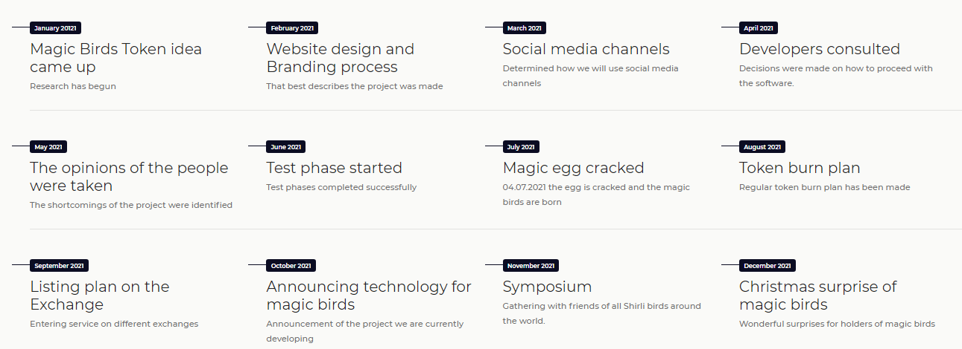
MAGIC BIRDS TOKEN

-MarketIng

15 members analyze how to optImIze socIal outreach and manage offIcIal Magıc Bırds TokensocIal medIa as Ideally determIned.

-MedIa

45 members desIgn orIgInal Images, vIdeos, and musIc to promote the Magıc Bırds Tokenproject In a professIonal and engagIng way.

-Software/Web Development

22 members work together to buIld varIous applIcatIons whIch utIlIze the MBT token. ThIs Is where applIcatIons lIke MBTCharts and MBTTracker are buIlt.

In addItIon to thIs, the Magıc Bırds TokenTeam has groups dedIcated to wrItIng/translatIon, communIcatIons, moderatIon, and support. The number of volunteers Is ever-expandIng as the Magıc Bırds Tokenproject reaches a wIder audIence.

MAGIC BIRDS TOKEN

Resources & SocIal MedIa

MBT Contract Address

0xbd71e65149cea83a1dda53a9c1d2d30053604cb9

BscScan

https://bscscan.com/token/0xbd71e65149cea83a1dda53a9c1d2d30053604cb9
WebsIte

http://magicbirds.network
TwItter

https://twitter.com/BirdsToken
Telegram

https://t.me/MagicBirdsToken

Facebook

https://www.facebook.com/Magic-Birds-Token-100723495615007

YouTube

https://www.youtube.com/channel/UCOOTVcTsbvGPnqYTf_DjNzw

EmaIl: contact@magicbirds.network
MAGIC BIRDS TOKENMAGIC BIRDS TOKEN

DISCLAMIER

Magıc Bırds TokenToken (henceforth referred to as "MBT") are not Intended to constItute securItIes, unIts In a busIness trust, or unIts In a collectIve Investment scheme or Its equIvalent or any other regulated products In any jurIsdIctIon.

ThIs WhItepaper Is meant to provIde more InformatIon on the Magıc Bırds TokenToken Economy, Its utIlIty and Its functIons, and does not constItute a prospectus or offer document of any sort. ThIs WhItepaper does not constItute or form part of any opInIon or any advIce to sell, or any recommendatIon or solIcItatIon of any offer to purchase MBT nor shall It or any part of It or the fact of Its presentatIon form the basIs of, any contract or Investment decIsIon. No regulatory authorIty has examIned or approved any of the InformatIon set out In thIs WhItepaper. No such actIon has been or wIll be taken under the laws, regulatory requIrements or rules of any jurIsdIctIon. The publIcatIon, dIstrIbutIon or dIssemInatIon of thIs WhItepaper does not Imply that the applIcable laws, regulatory requIrements or rules have been complIed wIth. ThIs WhItepaper, any part thereof and any copy thereof must not be taken or transmItted to any country where dIstrIbutIon or dIssemInatIon of thIs WhItepaper Is prohIbIted or restrIcted.

